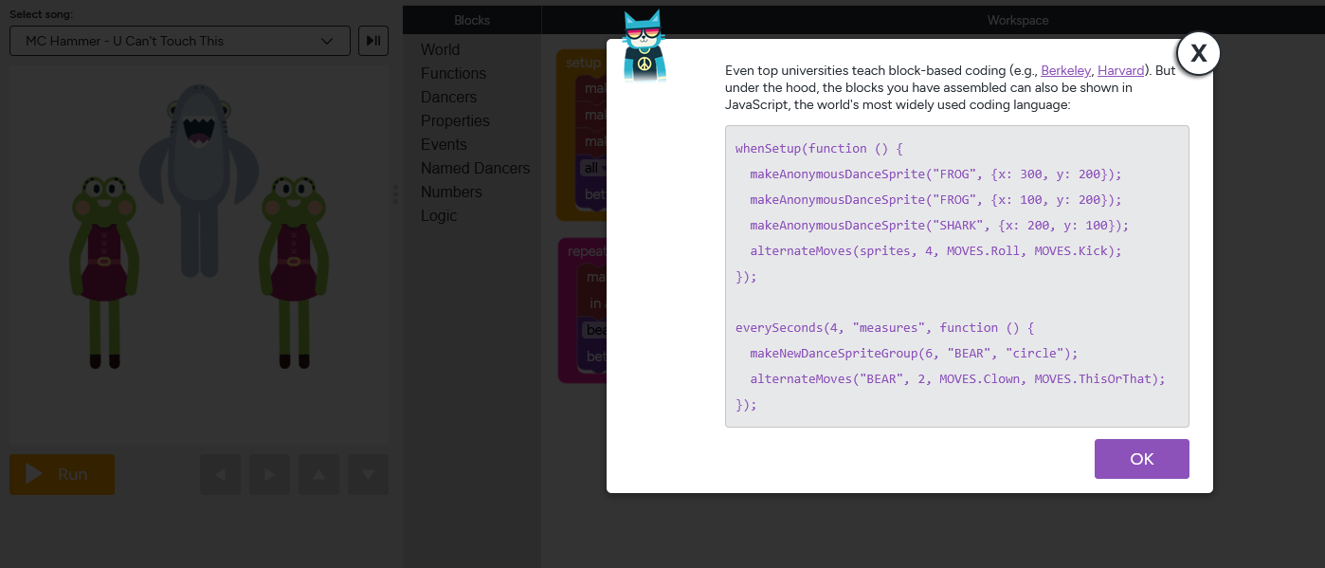
Robert Herrera’s programming project making a dance party on code.org this is the code used.

